

* Explore developing a career path
* Preparing for a raise
* Grow in professionalism
* Learn why to create more value
* And more…

This class is for you if…

* You are working and are wondering what it’s going take to ***get a promotion***.
* You are ***looking*** ***for work***.
* You want a ***raise***.
* You want to make a ***career/job move***.

Birch Community Services

17780 NE San Rafael

Portland, OR 97230

Phone: 503.251.5431

Register at: www.birchcommunityservices.org

Where:

**BCS Classroom**

When:

**Saturday, June 25th**

Time:

**9am – Noon**

Instructor:

**Dino Biaggi**

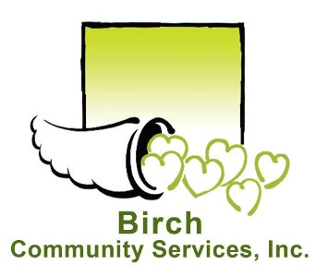

## BCS Presents…

# Career Development